North Lincolnshire Council
Daily Event Analysis
21st December 2010

Overview
The Amvale Osiris measured a daily mean PM₁₀ concentration of 70µg/m³ on Tuesday 21st December 2010 exceeding the allowed 50µg/m³ as a daily mean. The East Common Lane TEOM measured a daily mean concentration of 52µg/m³ which also exceeds the allowed 50µg/m³. The graph below shows the fluctuation in concentration through the day at both sites.

A check of the data has revealed elevated concentrations of PM₁₀ between 13:45 and 15:45 at Amvale. During this period the Amvale Osiris measured a mean concentration of 125µg/m³ and the East Common Lane TEOM 39µg/m³. It was also observed later in the day elevated concentrations of PM₁₀ between 22:00 and 23:15 at East Common Lane. During this period the East Common Lane TEOM measured a mean concentration of 138µg/m³ and the Amvale Osiris 27µg/m³.

Met Conditions

The wind within the first 2 hour period of focus ranged between 345° and 27°. Wind speeds averaged at 1.9 m/s. The wind within the second 1 hour 15 minute period of focus ranged between 320° and 1°. No rain was measured throughout the day. Ground conditions were similar to the 19th & 20th , snow and a hard frost covered all exposed locations.

Episode Wind Range

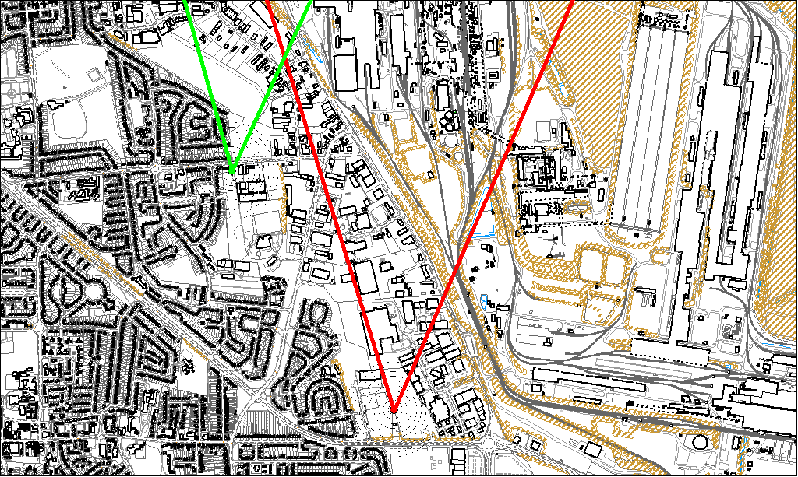

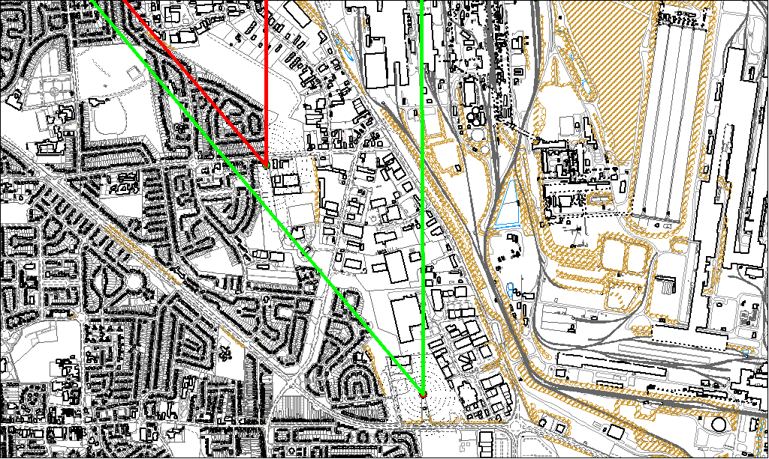
Map 2

Potential Sources

Map 1 shows the Amvale Osiris (indicated by the red lines) and the East Common Lane TEOM (indicated by the green lines). At this point the Amvale Osiris exceeded and the East Common Lane TEOM was under 50µg/m³. It is likely therefore that at this point in time they were affected by different sources. The area in which the red and the green lines intersect is unlikely to contain the source. This has become a common exceedance situation at Amvale, NNE winds contain concentrations causing an exceedance at Amvale. The likely sources include:

- Blast Furnaces
- Caparo
- Appleby Coke Ovens

Map 2 shows the East Common Lane TEOM (indicated by the red lines) and the Amvale Osiris (indicated in green). During this period the East Common Lane TEOM exceeded and the Amvale Osiris was under 50µg/m³. Therefore the area within the green lines is unlikely to contain the source of the exceedance. It is unusual for East Common Lane to exceed during periods of NW winds. Further investigation will be undertaken should this become a regular issue.

